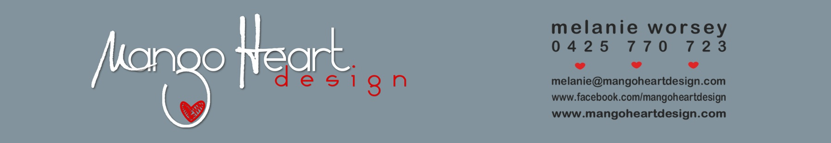

fatherS DAY Order Form
Details of person ordering design:
Name –
Address –
Contact Number –
Email Address –

Delivery and postage options incur additional cost.
Quoted times for completion conditioned on levels of communication, printing availability, individual requirements and personal circumstances.
Colours may vary slightly from those shown. Differences may be due to screen settings, paper specifications and printing variabilities.

Information for design:
Background colour (black/blue/tan/charcoal) –
Frame colour (white/dark brown/black) –

If personalised please provide recipients name and date of birth OR ONE other line of information –

